Name |  | Class
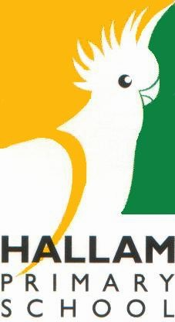

2024
Year 1 / 2
Parent Information Booklet

2024 YEAR 1/2 STAFF

12A | Room 1 | Ms Junlei Chen
12B | Room 4 | Ms Channiel Winter
12C | Room 5 | Mrs Nadine White (Mon, Tues, Wed, Thurs)  Mrs Dianne Burns (Fri)
12D | Room 18 | Mr Jordan Jameson
12E | Room 19 | Ms Robyn Unthank (Mon, Tues, Wed, Fri)  Mrs Dianne Burns (Thurs)
Intervention | STEM Centre | Mrs Lynda Morgan (MiniLit)
Mrs Nadine White (Team Leader)
Mrs Razia Mouradi (Multi-Cultural Education Aide)
Mrs Kathryn Sands (Education Support Aide)
Mrs Ashani Rodrigo (Education Support Aide)
Ms Mikayla Morgan (Education Support Aide)

SPECIALIST PROGRAM TIMETABLE
Further information about each of these programs can be found towards the end of this booklet.

 | PHYSICAL EDUCATION | STEM PROGRAM | ARTS - VISUAL | ARTS - PERFORMANCE
Monday | 12D,12C | 12D,12C | 12A,12E | 12E, 12B
Tuesday
Wednesday | 12A, 12E | 12A, 12B,12E | 12C, 12B, 12D | 12A,12C, 12D
Thursday
Friday | 12B
2
SPECIALIST PROGRAM TEACHERS
Mr Rob Coxon (Physical Education)
Ms Amy Kong (STEM – Science, Technology, Engineering and Maths)
Mrs Cheryl King (Arts - Visual)
Mrs Amanda Conder (Arts – Performance)
Mrs Kathy Van Eck (Kitchen program)
Mrs Deanne Ashton-Smith (Garden program)

HOW CAN I HELP MY CHILD TO MAXIMISE THEIR
LEARNING OPPORTUNITIES AT SCHOOL?
School life is always a busy and hectic time. With so many day-to-day things to remember, we have compiled a concise list of tips to assist.

BEFORE SCHOOL
Gates are opened at 8:30am for students to attend Breakfast Club. Parents/Carers are reminded that Yard Duty and First Aid teachers are rostered on from 8:45AM. Prior to this, staff are arriving at school, attending meetings, preparing for the day, and undertaking administrative tasks. They are not out in the school ground where a student might get into difficulties or be injured.

SCHOOL TIMES
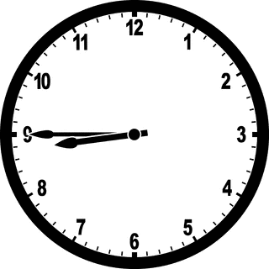
Students are encouraged to be at school by 8:45am for a 9:00am start. After 9:00am, late students must be signed in at the Kiosk in the office by their parent/guardian before going to their classroom. School concludes at 3:30pm and students are usually dismissed from their classrooms. Parents/Guardians are advised to pick their child up between 3:30-3:45pm. If your child is absent, please notify the school via Compass, or send a written note or medical certificate when they return, explaining the absence.

9.00am – 11.00am | Morning session
11.00am – 11.30am | Recess
11.30am – 1.30pm | Middle session
1.30pm – 1.40pm | Lunch in the classroom
1.40pm – 2.30pm | Lunchtime
2.30pm – 3.30pm | Afternoon session
3.30pm | Dismissal

BREAKFAST CLUB
Breakfast Club operates every morning from 8:30am in our Hall and is co-ordinated by Mrs Charlotte Cox. Students may choose from a variety of options including cereal, toast, spaghetti and fruit. All Hallam PS students are welcome to come to Breakfast Club.

FRUIT BREAK / RECESS / LUNCH
Hallam PS is a healthy eating school, and we encourage our students to bring health foods for snack and lunch. There is an opportunity for students to have a Fruit Break (fruit or vegetables only) around 10.00am. This is followed by a snack break at recess (10.50am).
Snack ideas | Lunch ideas
- cut up fruit  - vegetable sticks  - cherry tomatoes  - cheese  - yoghurt | - sandwich  - wrap  - mini quiches  - vegetable slices
We have a strict ‘no-sharing food’ policy at Hallam PS, as some of our students have severe allergies or restricted diets. Students require a drink bottle filled with water at school. Water is good for hydration and easily cleaned up if spilt. Juices and cordial should not be sent in drink bottles.

**Lollies found at school will be confiscated and returned to the student/parent at the end of the school day.
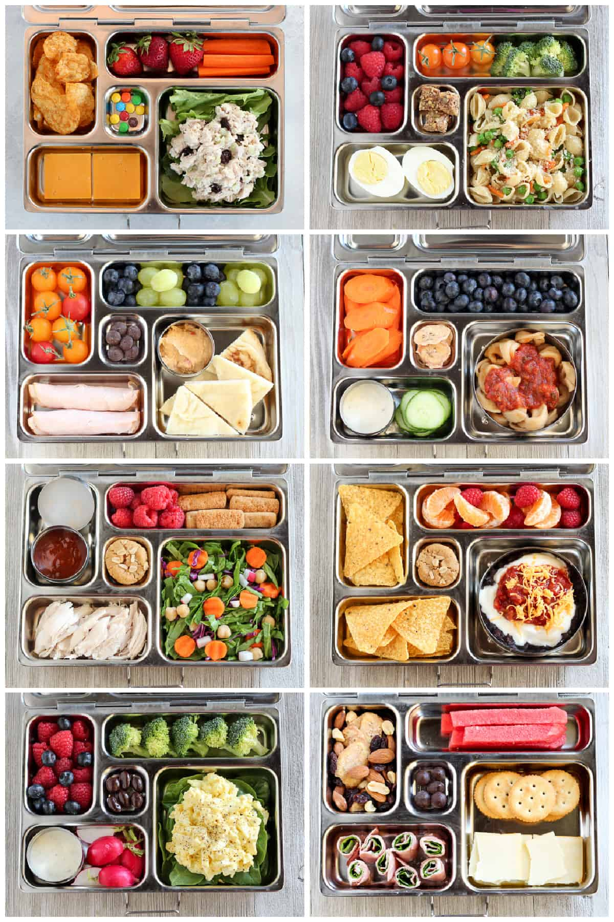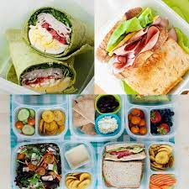

It is essential that students brush their teeth every day before school.

What you can do to help maintain healthy teeth:
- Choose fresh fruit over dried fruit, as dried fruit will leave a sticky residue on your teeth and can contribute to tooth decay.
- Drink fluoridated tap water and plain milk instead of soft drinks, juice or cordial.
- Limit sweet drinks, including fruit juices (even if diluted, fruit juice contains natural sugars which can lead to tooth decay).
- Brushing your teeth and cleaning between your teeth is important because it removes plaque. If the plaque isn’t removed, it builds up and can cause tooth decay and gum disease. You should brush your teeth at least twice every day.

CELEBRATIONS AT SCHOOL
Birthdays will be acknowledged and celebrated in the classroom. Students are unable to bring any food including cakes, lollies or chocolate to school to share with their friends as many students have food allergies or follow specific diets.

PERSONAL ITEMS
Please ensure ALL items are CLEARLY NAMED. Un-named items are placed in Lost Property located in Building A.

ASSEMBLIES
A school assembly for students in Prep – Year 2 is held on Friday at 2.30pm in the hall. The assembly includes notes and reports from the Principal, staff and Student Leadership Team. Parents and carers are welcome to attend. ‘Worker of the Week’ awards are presented at the assembly.

LIBRARY
Borrowing from the library occurs on Thursday. Borrowed library books need to be stored in a library bag to prevent damage from leaking drink bottles or food in the school bag. Students will be unable to borrow a new book until they have returned their borrowed book.

ATTENDANCE
Daily school attendance is important for all children and young people to succeed academically, and to ensure they do not fall behind socially or developmentally.
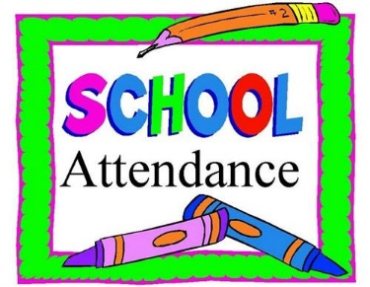
Children and young people who regularly attend school and complete Year 12 or an equivalent qualification have better health outcomes, better employment outcomes, and higher incomes across their lives. It is important that children develop habits of regular attendance from an early age.

- Regular, on-time attendance is essential for all students.
- When students are not at school on time, they miss important instructions given by the teacher at the beginning of the morning session.
- Late arrivals can cause increased anxiety.
- Allow extra time for travel to school in the mornings to avoid a disruptive, late arrival.
- A parent/carer is required by the Department of Education to provide a written explanation for their child’s absence/s from school.
- Absences for birthdays, shopping, meeting family/friends at the airport are unauthorised absences from school.
- Staff closely monitor school attendance and keep Student Wellbeing personnel informed.

Parents are legally required to ensure their child attends school and to provide an explanation for any absence from school. The school must record, in writing, the reason provided by the parent. The principal must be able to determine, from the records, if the reason provided is reasonable in terms of the parent meeting their legal obligations.

Parents should inform the school of the reason for their child’s absence so that the school can:
- determine if the child’s absence needs to be excused by the principal, in line with school policy and these guidelines
- determine the appropriate follow-up to ensure the child’s education and wellbeing is supported
- record if the parent has a reasonable excuse for not meeting their obligation to ensure their child attends school each day.

If your child is absent, please notify the school via Compass, or send a written note or medical certificate when they return, explaining the absence. Where possible, parents should inform the school in advance of upcoming absences.

If you have any Student Wellbeing concerns, please contact Shirley Fletcher, Assistant Principal/Wellbeing on 9703 1536.
Department of Education Attendance Policy: In accordance with the Education and Training Reform Act 2006, schooling is compulsory for children and young people aged from 6-17 years unless an exemption has been granted. Parents/guardians must enrol a child of compulsory school age at a registered school and ensure the child attends school at all times when the school is open for instruction. Schools must maintain attendance records, identify and follow up unexplained absences, and develop policies to support and maintain attendance. Further information regarding the Department of Education Attendance Policy can be found at https://www2.education.vic.gov.au/pal/attendance/policy

UNIFORM
All students are required to be in full School Council-approved uniform daily. This includes a broad brimmed bottle-green hat during Term 1 and Term 4, consistent with our SunSmart policy.

SHOES: Shoes must be plain black or white only and cover the toes:
 |  | `
 | 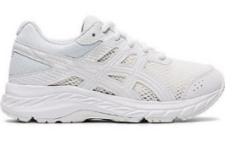 | 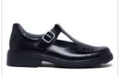 | 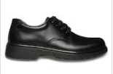
plain black  runners | plain white  runners | black school  shoes | black school  shoes

HAT
Bottle green, wide brim hat ONLY

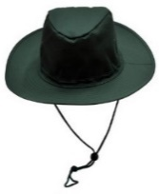 | 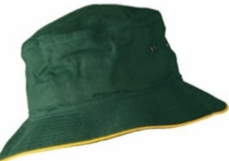 | 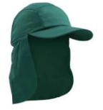
bottle green, wide brim | no bucket hats | no legionnaires hats

CLOTHING
Bottle green and gold, items do not need to have the school logo:

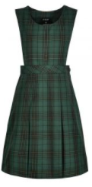  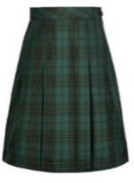 | 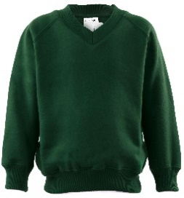 | 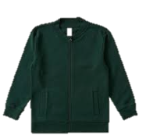 | 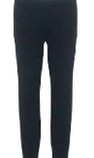
tunic / detachable skirt  Only available at PSW | green windcheater | green jacket (no hood) | black leggings can be worn under a dress
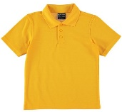 | 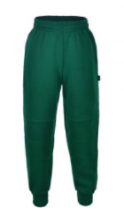 | 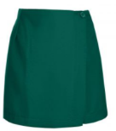  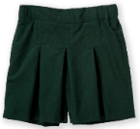 | 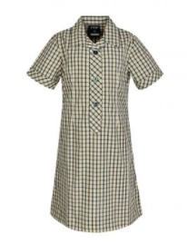
gold polo t-shirt  long or short sleeves | green tracksuit pants | green shorts or PSW skort  (TARGET skort is  NOT acceptable) | school dress  Only available at  PSW

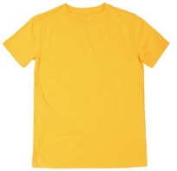  yellow t-shirt without a collar | 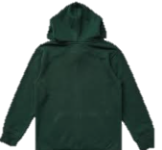  windcheaters with hoods | 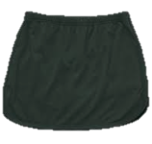  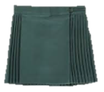  skirts | 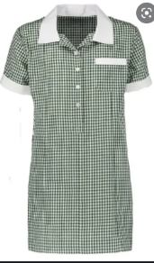  green gingham school dress

• Socks, headbands, scrunchies and ribbons are to be white, yellow or bottle green. Leggings/tights are to be bottle green.
• Religious headwear must be bottle green, yellow or white.
• A watch, and one pair of plain stud earrings or sleepers worn in the ears is the only acceptable jewellery.
• Extreme hair colors (e.g., green, pink or purple rinses) and/or extreme hairstyles (e.g., spikes, shaved shapes or Mohawks) are not permitted.
• Nail polish and cosmetics are not to be worn at school.
• Bottle green, broad-brimmed hats, consistent with our SunSmart policy, must be worn outside in Terms 1 and 4. Legionnaire hats and bucket hats are not permitted. Hats are not to be worn inside.

**Our full School Council-approved Uniform policy is available on the school website.

CURRICULUM
All programs are based on the Victorian Curriculum F–10 Version 2.0. Information about the curriculum can be found at Victorian Curriculum F–10 Version 2.0 (vcaa.vic.edu.au)

Year 1 and 2 students are taught and assessed on the following areas over two years :
English | Mathematics | Health and Physical Education
- Reading and Viewing  - Writing  - Speaking and Listening | - Number and Algebra  - Measurement and Geometry  - Statistics and Probability | - Movement and Physical Activity  - Personal, Social and Community Health
The Arts | Technologies | The Humanities
- Dance  - Drama  - Music  - Visual Arts  - Media Arts | - Design and Technologies  - Digital Technologies | - Geography  - History
Personal and Social Capability | Language other than English (LOTE)  Auslan | Science
Critical and Creating Thinking | Ethical Capability | Intercultural Capability

2024 Units of Investigation –
Term 1 | Places and Spaces
Term 2 | Tip Toe Through Our World
Term 3 | Celebrating Differences
Term 4 | Robot Buddies

KITCHEN GARDEN PROGRAM (Semester 2)
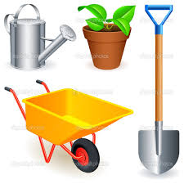
Stephanie Alexander, well-known chef and food writer, wants young children to learn how to grow and eat healthy food every day of their lives. Hallam Primary School began working in partnership with the Stephanie Alexander Kitchen Garden Foundation many years ago, and we have our own garden and kitchen to provide this exciting experience for your child.

In Semester 2, each fortnight the Year 1/2 classes participate in a 50-minute garden session in the school garden. The students work with our garden specialist, Deanne Aston-Smith, digging, weeding, planting, propagating and harvesting, with assistance from our willing helpers (School Council-approved volunteers). Students also participate in Kitchen sessions fortnightly in our student kitchen. Our kitchen specialist, Kathy Van Eck, organises this program in consultation with our teachers, and the prepared meal is shared.
Reference: www.kitchengardenfoundation.org.au

READING
Students are expected to read their take-home readers at least 5 times a week and have the reading diary signed by an adult. Students will change their take-home readers Monday, Wednesday and Friday. Repeated reading of the same text allows students to develop fluency and comprehension.

SPELLING/HANDWRITING
Students are introduced to, and learn, the 45 speech sounds made by the 70 basic written codes in the English language. They practise blending the phonograms into whole words and are explicitly taught to make the sound-symbol connection in words. Students participate in clinical sessions teaching correct pencil grip and correct letter formation when handwriting.

HOMEWORK (SPELLING)
Spelling homework will be distributed on Mondays, starting in Term 1. Students are expected to return their completed homework to the class teacher by Friday.

STUDENT-PARENT-TEACHER CONFERENCE
There is overwhelming evidence that where a positive and productive partnership exists between home and school, students’ learning is extended. It is important that we, as educators, and you, as parents, are aware, alert and supportive of each child’s individual needs, talents and learning behaviours. A critical factor in providing such a supportive learning environment for all students is the continued communication and cooperation between the teacher and the student’s family. As well as encouraging you to talk to your child’s teacher throughout the year, we do this through Student-Parent-Teacher Conferences. Student-Parent-Teacher Conferences will be scheduled in Term 1 and Term 3. At this time, you will receive a letter from your child’s teacher inviting you to select a time when you can come to school.

EVENTS
Students at Hallam PS will have the chance to participate in a variety of activities to enhance their learning at and beyond school. At other times, special events and fundraising activities will be scheduled. Notices and permission forms can be accessed via the Compass app. Payments can also be made on Compass or at the school office. All notices have a due date and time so that bookings can be finalised. Payments brought after the due time and date cannot be accepted, and students will then be unable to participate in the activity.

CSEF (Camps, Sports and Excursions Fund): Parents/carers who hold a current Centrelink Health Care card or Pensioner Concession Card are eligible to apply for CSEF. Funds are paid directly to schools and can be used for students to attend camps, sports and excursions. Parents may then tick the CSEF box on Compass when payment for one of the activities is required. Please speak to the admin staff in the school office for further information.

CHILD SAFE STANDARDS
Hallam Primary School is committed to the safety and wellbeing of children and young people. Our school community recognises the importance of, and responsibility for, ensuring our school is a safe, inclusive and enriching environment that respects and fosters the dignity and self-esteem of children and young people, and enables them to thrive through their learning and development. The Child Safe Standards are compulsory standards for all organisations that provide services to children. The VRQA and DE are responsible for ensuring that schools are compliant with the Child Safe Standards. During the 2019 school review, Hallam Primary School demonstrated compliance with the required Standards. Our website contains further information regarding our Child Safe Policies and Child Safe Code of Conduct. Hallam Primary School is again scheduled for review in 2024. Parents/carers are advised, and should be aware, of their responsibilities in relation to the Child Safe Standards and refrain from taking photos that include other children or approaching students in the playground. You are asked to respect the privacy of others and the requirements in relation to the Child Safe Standards at Hallam Primary School.

Health and Physical Education
The Health and Physical Education Program consists of a 60-minute specialist session each week and a 60-minute physical fitness session undertaken by the classroom teachers and specialist teacher each week. The Physical Education lessons aim to develop students’ skills across areas of Fundamental Movement Skills (e.g., running, overarm throw, catching, kicking and forehand strike), co-operative team games, ball-handling skills, Gymnastics, Cross Country, Athletics, Handball, Soccer, Basketball, Hockey, AFL, inclusive fun games, physical fitness and sport education.
Students participate in a variety of activities, drills and games, and full participation is always encouraged. The students are also encouraged to develop qualities of good sportsmanship, such as fair play and teamwork.
School hats are compulsory during Terms 1 and 4, and it is recommended that students wear appropriate footwear. Students are also expected to bring a drink bottle (water only) to all Physical Education sessions.
In addition to lessons, students will be given opportunities to participate in a variety of sports clinics, a swimming program (Big Fish Little Fish), after school sport programs and whole school sports events such as the Cross Country Carnival, Fun Run and Hallam Junior Athletics Day. Dates and information for these programs will be distributed at relevant times throughout the year.
Mr Brendan McCarthy
2023 Physical Education Specialist/Sport Coordinator

The Arts 2023
In the Victorian Curriculum, the Arts includes Dance, Drama, Media Arts, Music, Visual Arts and Visual Communication Design. Students from Prep to Year 6 attend one hour of combined Visual and Media Arts each week as well as an hour of Performance Arts.
Visual and Media Arts
Visual and Media Arts sessions involve students in learning the elements of art as well as the principles fundamental to creating their art.
Students use creative and critical problem-solving processes to initiate and progress their arts ideas. They make conscious choices about how to express thoughts and feelings in their artworks.
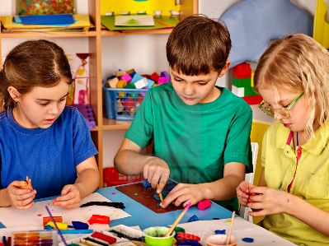
Students are also guided towards expanding their awareness of the arts in Australian society by being encouraged to move beyond familiar experiences and explore a wider range of cultures and points of view. As they make and respond to visual artworks, students are exposed to different forms and styles of art through varied social and cultural contexts.
Students explore the techniques of historic and contemporary artists, locally and globally. They produce 2D and 3D artworks to develop skills in areas such as designing, painting, drawing, collage, construction, printmaking, digital arts and sculpture. Students experiment with different methods, and make informed choices on the use of a wide variety of materials.
It is recommended that students wear a smock or old shirt to protect their school uniform.
Mrs Cheryl King
2023 Visual Arts Specialist
S T E M
Students from Prep to Year 6 will take part in a one-hour STEM lesson each week. This creates links between Science, Technology, Engineering and Mathematics through expansion of each student’s vocabulary and knowledge.

Students will work on developing experimental, observational and team work skills. Lessons will explore ‘Science as a Human Endeavour’ and will develop ‘Science Inquiry Skills.’ Throughout the year students will be exposed to the four conceptual Science strands of Biological, Earth and Space, Chemical, and Physical sciences. Students will be given the opportunity to explore Flora and Fauna, Geography, Properties of Materials and Energy.

The Digital Technologies curriculum: Data and Information, Creating Digital Solutions and Digital Systems will be incorporated into each unit of work. Students at each year level will be exposed to different digital resources including; 3D-Printing, Green Screen, Prime VR, iPads – including AR apps, Google Apps for Education and LEGO kits. Students will be given the opportunity to use coding and programming software including Scratch and Scratch Jnr. They will also operate robots such as Bee-Bots, Dot and Dash, NAO and their associated programs.

The STEM lesson format incorporates the school instructional design process:
- Introduction - Looking at imagery, video clips, instructions and demonstrations
- Embedded Learning - Activities, experiments, engineering and observations
- Reflection - Discussion and evaluation

Through participation in regular STEM lessons, we want our students to:
- Be interested in and understand the world around them
- Engage in discussions about Science, Technology, Engineering and Mathematics
- Be able to identify questions, investigate and draw evidence-based conclusions
- Make informed decisions about the environment and their own health and wellbeing
- Follow the Engineering Design Process (Ask, Brainstorm, Plan, Build, Experiment, Improve)
- Develop skills to utilise technology effectively

At Home: Great resources for students to try at home to help consolidate topics are:
https://www.abcya.com/games/category/science | https://pbskids.org/games/science
http://www.code.org | https://pbskids.org/games/engineering

Mrs Jessica Farrar and Mrs Jade Way
2023 STEM Specialists

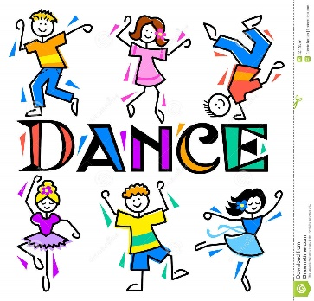

Performing Arts - Year 1/2

Students in Year 1/2 participate in a one-hour Performing Arts session each week with Amanda Conder.

During Performing Arts sessions, the students have the opportunity to develop their creative and expressive capacities by learning about the different practices, disciplines and traditions that have shaped the expression of culture locally, nationally and globally. Students are both artist and audience in the Arts. They make and respond and learn to appreciate the specific ways this occurs in different disciplines. Performing Arts sessions will focus on Music, Dance and Drama.
Music - Music Education is fundamental to the learning of every individual, as music is a language that integrates in all cultures and societies. The aim is to stimulate, develop and maintain an interest in and a love of music. Music develops students’ imaginations, intellectual curiosity, builds self-confidence, self-awareness and strengthens interpersonal skills.
Students use voice and body percussion to experiment with the elements of music and create contrasting musical ideas such as noise and silence, faster and slower, longer and shorter, higher and lower, louder and softer, happy and sad. They play and sing rhythmic and melodic phrases and patterns using their voices, tuned and untuned instruments. Students complete music activities from the Music Room Program by Bushfire Press.
Drama - The students make and present drama using the elements of role, situation and focus in dramatic play and improvisation. They use voice, facial expression, movement and space to imagine and establish role and situation. The students manipulate objects, props, puppets, 2D images and available technologies to create stories. Students describe what happens in drama they make, perform and view.

Dance - Students use the elements of dance and fundamental movement skills to make and safely perform, dance sequences that express ideas. They communicate about dances they make, perform and view, and discuss where and why people dance.

Mrs Amanda Conder
2023 Performing Arts Specialist

