

**2024**

**YEAR 5/6**

**PARENT**

**INFORMATION**

**BOOKLET**

|  |
| --- |
| **2024 YEAR 5/6 STAFF** |

|  |  |  |
| --- | --- | --- |
| **5/6A** | Room 10 | **Mr King Tangso (Team Leader)** |
| **5/6B** | Room 12 | Ms Robyn Unthank |
| **5/6C** | Room 11 | Ms Paige Dang |
| **5/6D** | Room 13 | Ms Sarah Pearce-Edwards |
| **Intervention** | Room 3 | Mrs Amanda Biemans  (Tutor Learning Initiative – Literacy) |
| Ms Carmelita Gomes (Education Support)  Mrs Donna Hamilton (Education Support)  Mr Jonathan Carmody (Education Support) | | |

**PROGRAM SPECIALISTS TIMETABLE Semester 1**

|  |  |  |  |  |
| --- | --- | --- | --- | --- |
|  | **PHYSICAL EDUCATION** | **STEM PROGRAM** | **ARTS - VISUAL** | **ARTS - PERFORMANCE** |
| **Monday** | **56C** | **56D** | **56A** | **56B** |
| **Tuesday** |  |  |  |  |
| **Wednesday** |  |  |  |  |
| **Thursday** | **56D**  **56A**  **56B** | **56A**  **56B**  **56C** | **56B**  **56C**  **56D** | **56C**  **56D**  **56A** |
| **Friday** | **56 Sports** | | | |

|  |
| --- |
| **PROGRAM SPECIALISTS** VisualartsVisualarts |
| **Mrs Cheryl King** (Arts - Visual)  **Mrs Amanda Conder** (Arts – Performance)  **Mr Rob Coxon** (Physical Education)  **Ms Amy Kong** (STEM program)  **Mrs Kathy Van Eck** (Kitchen program)  **Mrs Deanne Ashton-Smith** (Garden program) |

**HOW CAN I HELP MY CHILD TO MAXIMISE THEIR  
LEARNING OPPORTUNITIES AT SCHOOL?**

|  |
| --- |
| **BEFORE SCHOOL** |

Gates are opened at 8:30am for students to attend Breakfast Club. Parents/Guardians are reminded that **Yard Duty and First Aid teachers are rostered on duty from 8:45AM**. Prior to this, staff are arriving at school, attending meetings, preparing for the day, and undertaking administrative tasks. **They are not out in the school ground where a student might get into difficulties or be injured.**

|  |
| --- |
| **SCHOOL TIMES** |

We encourage students to be at school at 8:45am each day because school begins at 9:00am. This gives students time to go to the toilet, undertake hand hygiene routines, have a drink and settle in before the music begins at 8:55am. School concludes at 3:30pm and students are generally dismissed from the classrooms. Parents/Guardians are advised to pick their child up between 3.30-3.45pm. We ask parents and siblings to refrain from standing in the gateways, as these can become very congested areas.

**A medical certificate and/or a note, signed by the parent/guardian, is required to explain any student absence.**

|  |  |
| --- | --- |
| 9.00am – 11.00am | Morning session |
| 11.00am – 11.30am | Recess |
| 11.30am – 1.30pm | Middle session |
| 1.30pm – 1.40pm | Lunch in the classroom |
| 1.40pm – 2.30pm | Lunchtime |
| 2.30pm – 3.30pm | Afternoon session |
| 3.30pm | Dismissal |

|  |
| --- |
| **BREAKFAST CLUB** |

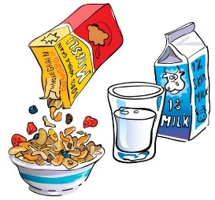Breakfast Club operates each day before school between 8:30am and 8.45am in the school hall. Teachers and Education Support Staff, assisted by some student helpers, supervise Breakfast Club and assist with preparation/pack up. All Hallam PS students are welcome to come to the hall to have a bowl of cereal with fruit/milk, baked beans on toast or toast with jam or vegemite, even if they have already had some breakfast at home. A healthy breakfast provides students with a great start to a busy day of learning and playing with friends.

|  |
| --- |
| **FRUIT BREAK / RECESS / LUNCH** |

****Starting the school day with sugary snacks or salty potato chips is not in the best interests of any learner, and we all want the best for our children. A solid breakfast of quality cereal, toast, yoghurt, milk, juice and/or fruit is a great way to begin learning. Hallam PS is a healthy eating school, and we encourage our families to ensure their children have breakfast every day and bring healthy foods for snack and lunch. Students are welcome to attend Breakfast Club and enjoy a healthy start to the day with cereal, fruit and/or toast… at no cost!

Lunch needs to be a substantial sandwich or wrap with fruit/vegetable sticks/cheese/yoghurt and a bottle of water. Soft drinks and cordials are not permitted on the tables in classrooms. Please keep bags of chips/sweet slices/cakes/biscuits, etc., for special times or as an extra with a sandwich.

We have a strict ‘no-sharing food’ policy at Hallam PS, as some of our students have severe allergies to food colourings, preservatives, additives, nuts and sugar.

**\*\* Please remember: No lollies at school.**

Lollies found at school will be confiscated and returned to the student/parent at the end of the school day.

**Try these tips:**

* A close-up of vegetables in a container

  Description automatically generatedThink about what your child likes to eat at home and try to translate that into a lunch box option.
* Try cutting up some carrot sticks or putting in a handful of cherry tomatoes, celery, cucumber, lettuce, avocado etc.
* Consider apples (sturdy and hard to squash), and also think about cutting softer fruit up and putting it into a smaller container for protection. Berries and kiwi fruit survive very well this way.
* Dairy can be hard to include, particularly in hot weather. If you can't safely get a yoghurt into the lunch box, make sure you offer dairy when he/she comes home from school.
* Last night's leftovers in a container with a small spoon can make a welcome change.
* Try putting together a small picnic in his/her lunch box - slices of tomato, ham, grated carrot, grated cheese and some bread and butter - so students can build their own sandwich.
* Homemade pikelets, mini quiches, vegie slices are a great snack - easy to make ahead of time, they're filling and don't require any extra toppings.

|  |
| --- |
| **DENTAL HEALTH** |

**It is vital that students brush their teeth every day before school.**

For healthy teeth, food and drinks should be free of added sugar whenever possible.

Tooth decay is a diet-related disease. Sugars in the food and drinks you consume mix with the bacteria in the plaque on your teeth and produce acids. These acids attack the outer layers of the tooth (tooth enamel).

Consuming sweet food and drink between meals is a major cause of tooth decay; this is because there is no between-meal period for teeth to undergo recovery. The more often sweet foods and drinks are consumed, the higher the risk of tooth decay.

**What you can do to help maintain healthy teeth:**

* Limit sweet drinks, including fruit juices (even if diluted, fruit juice contains natural sugars which can lead to tooth decay).
* Choose fresh fruit over dried fruit, as dried fruit will leave a sticky residue on your teeth and can contribute to tooth decay.
* Drink [fluoridated](https://www.dhsv.org.au/dental-health/teeth-tips-and-facts/fluoride) tap water and plain milk instead of soft drinks, juice or cordial.
* [Brush your teeth](https://www.dhsv.org.au/dental-health/general-dental-advice/how-to-brush-your-teeth) at least twice a day. Brushing your teeth and [cleaning between your teeth](https://www.dhsv.org.au/dental-health/general-dental-advice/how-to-floss-your-teeth) is important because it removes plaque. If the plaque isn’t removed, it builds up and can cause tooth decay and [gum disease](https://www.dhsv.org.au/dental-health/teeth-tips-and-facts/periodontitis).

|  |
| --- |
| **ATTENDANCE** |

Daily school attendance is important for all children and young people to succeed in education and to ensure they don’t fall behind both socially and developmentally.

Children and young people who regularly attend school and complete Year 12 or an equivalent qualification have better health outcomes, better employment outcomes and higher incomes across their lives. **It is important that children develop habits of punctuality and regular attendance at an early age.**

**Regular, on-time attendance is vital for all students.**

* When students are not at school on time, they can miss out on important instructions given by the teacher first thing in the morning, or they may be too late to hand in monies/notices, etc. Late arrivals can also cause embarrassment and increase anxiety.
* Please allow extra time for travel to school in the mornings to avoid a disruptive late arrival.
* When absent from school, a parent/carer is required by the DE to provide an explanation for the absence to the school.
* Birthdays, shopping, meeting family/friends at the airport are unauthorised absences from school.
* Staff will closely monitor school attendance and will keep Student Wellbeing personnel informed.

**STUDENT ABSENCE:**

D:\Users\01309164\AppData\Local\Microsoft\Windows\Temporary Internet Files\Content.IE5\PEZICO75\MC900436161[1].wmfParents/Guardians are required to ensure their child attends school and to provide an explanation for their child's absence from school, and the Principal must record in writing the reason (if any) given by the parent. The Principal must be able to determine from the records if the excuse given was **reasonable** in terms of the parent meeting their legal obligations.

Parents should inform the school of the reason for their child’s absence so that the school can:

* determine if the child’s absence needs to be excused by the Principal, in line with school policy and these guidelines
* determine the appropriate follow up to ensure the child’s education and wellbeing is supported
* record if the parent has a reasonable excuse for not meeting their obligation to ensure their child attends school each day.

Where possible, parents should inform the school in advance of upcoming absences.

**Please refer to the DE website for further information** [www.education.vic.gov.au](http://www.education.vic.gov.au)

If you have any Student Wellbeing concerns, please contact   
Shirley Fletcher, Assistant Principal/Wellbeing. 9703 1536

|  |
| --- |
| **PERSONAL ITEMS** |

Please ensure **ALL of your child’s personal items are CLEARLY NAMED**. Named items can easily be returned to your child. Un-named items are placed in the lost property tub, which is located near the main office.

**Drink Bottle:** Your child will be participating in a Physical Education and 5/6 Sport Program of at least 2 hours each week. To ensure your child is well hydrated throughout the day, a water bottle is required. A blue plastic bottle with a black lid
Having a water bottle in the class helps your child to remain hydrated during the day. Runners are necessary for any sporting activity.

|  |
| --- |
| **KITCHEN GARDEN PROGRAM (Semester 1)** |

*******Stephanie Alexander, well-known chef and food writer, wants children to learn how to grow and eat good food every day of their lives. Hallam PS began working in partnership with the Stephanie Alexander Kitchen Garden Foundation several years ago, and now we have our own student kitchen to provide this exciting experience for your child.*

On Tuesdays*****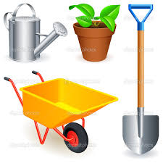* each fortnight the Year 5/6 classes participate in a one-hour Garden session. This is held in our garden at school. The students work with our garden specialist, Deanne Ashton-Smith, digging, weeding, planting, propagating, harvesting, etc. Students also participate in Kitchen sessions fortnightly. These are held in our student kitchen. Our kitchen specialist, Kathy Van Eck, organises this program in consultation with our teachers, and a meal is consumed at the end of each session.

**School Coordinator: Louisa Carey**

[www.kitchengardenfoundation.org.au](http://www.kitchengardenfoundation.org.au)

A Kitchen Garden is created to provide edible, aromatic and beautiful resources for a kitchen. The creation and care of a Kitchen Garden teaches children about the natural world, about its beauty and how to care for it, how best to use the resources we have, and an appreciation for how easy it is to bring joy and wellbeing into one’s life through **growing**, **harvesting**, **preparing** and **sharing** fresh, seasonal produce.

|  |
| --- |
| **HOME LEARNING TASKS** |

Class teachers monitor Home Learning, Home Reading, the use of student planners, school attendance and participation, and overall student achievement. Please help to support this worthwhile program by asking your child about their Home Learning Tasks and regularly signing their Record of Reading.

**READING AT HOME:** Students are expected to read for 20-30 minutes **at least five nights a week**. On two of these nights, students should read aloud to an adult or older sibling, if possible. Students who choose to read more than this are consistently rewarded by their teachers. Students should record this reading in their school planner each night, including the book title and pages read. Every time they finish a book, they should write one or two sentences about the book, for example detailing what they liked most about the plot/characters, if they would read another book by the same author, etc.

The school planner should be viewed and signed regularly by a parent as it is used as a communication log between parents and teachers.

Please work with us to ensure your child has access to a wide range of reading materials, for example newspapers, letters, recipes, TV guides, magazines and puzzle books. You might like to take your child to a local library (Doveton/Bunjil) so that they can choose books of particular interest to them.

**SPELLING/VOCABULARY:** Students will be given Home Learning Tasks related to the programs they are working on in class. Students who complete these tasks on a regular basis will be eligible for rewards at the end of each term.

Students will be given 20 spelling words each week, based on a particular theme/rule they have studied in class. They will neatly write out the words **three times** **each**. They will also be asked to choose at least six words from their spelling lists and either put each one in a ‘full sentence’ to demonstrate they know the meaning or look up and write out the dictionary definitions of these words. Please note, a ‘full sentence’ should begin with a capital letter, contain a subject and a verb, have a closing piece of punctuation (e.g. a full stop) and be a complete thought. Students will also be given a grammar and punctuation activity to re-enforce the concept of editing their writing.

[](http://www.google.com.au/url?sa=i&rct=j&q=&esrc=s&frm=1&source=images&cd=&cad=rja&docid=RwaVHRJKDAXNVM&tbnid=HsGf5m9x8AsfXM:&ved=0CAUQjRw&url=http://statsfun.com/art-materials-clipart/&ei=Kt7eUqqoJ4rJkgXEwYCACg&bvm=bv.59568121,d.dGI&psig=AFQjCNE7H5PAweZxvO2zG2R_F8y25WpCjA&ust=1390423857807260)**WAYS YOU CAN HELP YOUR CHILD WITH THEIR HOME LEARNING:**

* Talk through the expectations of the tasks
* Explain any terms that your child is unsure of
* Once students have completed written tasks, assist them to edit their work by:
  + Helping them identify words that may not be spelled correctly. Get them  
    to sound out the word and discuss which letter(s) are not correct.
  + Encouraging them to have another go.
  + Praising them for the parts that are correct.
  + Encouraging them to use a dictionary.
* Lastly, reading regularly can help your child with spelling confidence.

|  |
| --- |
| **INFORMATION AND COMMUNICATIONS TECHNOLOGY (ICT)** |

At Hallam PS, ICT is incorporated into all areas of the curriculum. Leased computers are updated every three years and each of the 5/6 classrooms has an interactive screen.

Students use a variety of programs to enhance their English and Mathematics skills and to research information related to the Units of Investigation. Students also have access to online learning sites, such as Typing Club, Epic and Mathletics, so they can revise and extend their skills at school and at home.

Hallam PS also has a Science and Technology Space where students will have access to a wide range of hands-on resources to help develop their critical thinking and digital skills. You will find more information about this program towards the end of this booklet. Students also have access to digital cameras, netbooks, video conferencing equipment, a suite of challenging software, the local network (Hallam PS Intranet) and the global network (Internet) to support their learning. Students gain this access at different levels based on parental permission. Access to our school’s ICT equipment also requires students and parents/ guardians to provide a signed HALLAM PS Internet Protocols agreement.

|  |
| --- |
| **UNIFORM** |

All students are required to be in full School Council-approved uniform daily. This includes a broad brimmed bottle-green hat during Term 1 and Term 4, consistent with our SunSmart policy.

**SHOES:** Shoes must be plain black or white only and cover the toes:

|  |  |  |  |
| --- | --- | --- | --- |
|  |  | A green check mark on a white background  Description automatically generated` |  |
|  | C:\Users\08540812\Desktop\Uniform pics\white runners.jpg |  |  |
| **plain black**  **runners** | **plain white**  **runners** | **black school**  **shoes** | **black school**  **shoes** |

**HAT**

**Bottle green, wide brim hat ONLY**

|  |  |  |
| --- | --- | --- |
|  |  |  |
|  |  |  |
| **bottle green, wide brim** | **no bucket hats** | **no legionnaires hats** |

**CLOTHING**

Bottle green and gold, items do not need to have the school logo:

|  |  |  |  |
| --- | --- | --- | --- |
|  |  |  |  |
|  | **C:\Users\08540812\Desktop\Uniform pics\school jumper no hood.jpg** |  |  |
| **tunic / detachable skirt**  **Only available at PSW** | **green windcheater** | **green jacket (no hood)** | **black leggings can be worn under a dress** |

|  |  |  |  |
| --- | --- | --- | --- |
|  |  |  |  |
| C:\Users\08540812\Desktop\Uniform pics\gold polo.jpg |  |  |  |
| **gold polo t-shirt**  **long or short sleeves** | **green tracksuit pants** | **green shorts or PSW skort**  **(TARGET skort is**  **NOT acceptable)** | **school dress**  **Only available at**  **PSW** |

|  |  |  |  |
| --- | --- | --- | --- |
|  |  |  |  |
| C:\Users\08540812\Desktop\Uniform pics\yellow tshirt.jpg  **yellow t-shirt without a collar** |   **windcheaters with hoods** | **skirts** | **green gingham school dress** |

• Socks, headbands, scrunchies and ribbons are to be white, yellow or bottle green. Leggings/tights are to be bottle green/black.

• Religious headwear must be bottle green, yellow or white.

• A watch, and one pair of plain stud earrings or sleepers worn in the ears is the only acceptable jewellery.

• Extreme hair colours (e.g., green, pink or purple rinses) and/or extreme hairstyles (e.g., spikes, shaved shapes or Mohawks) are not permitted.

• Nail polish and cosmetics are not to be worn at school.

• Bottle green, broad-brimmed hats, consistent with our SunSmart policy, must be worn outside in Terms 1 and 4. Legionnaire hats and bucket hats are not permitted. Hats are not to be worn inside.

**\*\*Our full School Council-approved Uniform policy is available on the school website.**

[**https://hallam-ps.vic.edu.au/community/#uniform**](https://hallam-ps.vic.edu.au/community/#uniform)

|  |
| --- |
| **BOOKLIST ITEMS** |

The 2024 Booklist detailed the items recommended for your child for their year level. Teachers spend considerable time formatting this list as each item enables your child’s maximum participation in the learning program. Should your child still require some items from the booklist, class teachers will contact you to discuss arrangements.

|  |
| --- |
| **STUDENT-PARENT-TEACHER CONFERENCES** |

Two formal conference times will be offered with your child’s class teacher during the year. This will provide an opportunity for the student, parent/s and the teacher to discuss progress and learning goals.

As has always been the case, if you would like to discuss any concerns you may have, please don’t hesitate to make an appointment with a 5/6 Team member at a mutually suitable time. It is always best if we are able to sort out small issues before they become bigger worries. Before school can often be hectic, but staff are available most afternoons.

|  |
| --- |
| **STUDENT LEADERSHIP TEAM** |

Student Leadership Team (SLT) members will attend weekly lunchtime meetings. They will assist with whole-school assemblies and participate in a leadership program that encourages them to build the skills necessary for leadership in our school. They will identify the qualities that make a good role model and develop these throughout the year.

|  |
| --- |
| **HALLAM PS 2024 PLANNERS** |

The student planner is an important organisational tool that students use daily during the school year. Students use their planner to record their home reading each week. The student planner can also be used as a communication log between parents and teachers, and to remind students about upcoming school events, approaching deadlines, forms that need to be returned, etc.

|  |
| --- |
| **NOTICES, EXCURSIONS AND EVENTS** |

Students at Hallam PS are fortunate to be able to participate in a variety of activities which enhance the curriculum and benefit everyone. Many activities and excursions provide students with ‘real-life’ experiences related to the current Unit of Investigation.

We would like to think that ALL of our students are encouraged to participate in all special events. The activities, events and excursions are an important and integral part of students’ learning. Some activities may have a cost attached, but many are free or a bus fare only. Please consider carefully when notices arrive home for you to sign and support your child’s learning by encouraging their attendance.

The following list contains some of the events we hope to offer our 5/6 students this year:

|  |  |
| --- | --- |
| * Lunchtime Clubs | * Free Dress Days |
| * Sporting Gala Days | * Lunchtime Discos |
| * HPS Cross Country Carnival | * Kitchen and Garden |
| * District Cross Country | * Premiers’ Reading Challenge |
| * District Athletics | * Excursions and Incursions |
| * District Swimming | * Leadership Program |
| * Swimming Program (BFLF) | * Transition Programs |
| * Hallam Sports Day | * 5/6 Module Sports Day |
| * Colour Fun Run | * Year 6 Farewell |
| * Movie Night | * Year 6 Celebration Day |

As buses and numbers of students must be confirmed in advance, all notices will have a clearly marked DUE DATE. Payments after the due date CANNOT be accepted and money will be returned home, resulting in your child being unable to participate in the activity.

Payments can now be made through COMPASS. A Hallam PS envelope will accompany notices home (or can be obtained from class teachers), and monies are to be returned in this envelope with your child’s details clearly filled out. Payments are given to the class teacher so they are able to be sent to the office in the class cash book before 9:30am. Money is processed through the office every day.

|  |
| --- |
| **HALLAM PS YEAR 6 TRANSITION PROGRAM** |

As soon as students enter the 5/6 Module, they begin their preparation for transition to secondary education. Several strategies are put in place in order to further their independent working skills.

These include: Pigeonholes instead of tubs  
 Different subject teachers  
 Student planners

All Year 5 students have been, or will shortly be, offered a copy of the Secondary Education booklet. This booklet provides a brief overview of the variety of Secondary Colleges operating in and around the Melbourne area. Parents with students currently in Year 5 are encouraged to start exploring the options available for their child as soon as possible.

**LOCAL SECONDARY SCHOOLS:**

The Secondary Colleges closest to Hallam PS are:

* Hallam Secondary College, Frawley Road, Hallam
* Gleneagles Secondary College, Reema Blvd, Endeavour Hills
* Fountain Gate Secondary College, Josephine Ave, Narre Warren
* Doveton College, 62 Tristania Street, Doveton

You can use this link to check you designated secondary school zone: <https://www.findmyschool.vic.gov.au/>

**SOUTHERN METROPOLITAN REGION PLACEMENT TIMELINE:**

The Department of Education and Training (DE) provides a strict timeline governing each step of the process. Detailed below is what to expect over the coming weeks and months (exact dates yet to be confirmed):

* From Week 1, Term 2 2024 – Government primary schools provide all parents/carers of Year 6 students information regarding how to access the Placement Information Pack – this pack includes the Application for Year 7 Placement 2025 form
* Friday 10 May 2024 – Application for Year 7 Placement forms must be returned to Hallam PS
* Wednesday 17 July 2024 – Government primary schools notify parents/carers of Year 6 students, in writing, of their Year 7 placement offers
* Thursday 18 to Friday 26 July 2024 – Parents/carers may submit written non-placement appeals to their preferred secondary school
* Date to be confirmed – Parents/carers informed of outcomes of written non-placement appeals
* Date to be confirmed – Year 7 Placement Acceptance Slips must be returned to Hallam PS
* Tuesday 10 December 2024 – Secondary schools host an Orientation Day for all Year 6 students

|  |
| --- |
| **ASSEMBLY TIMES** |

Assemblies will be held weekly in the hall on Fridays. Year 5/6 students will assemble from 3:00pm-3:20pm. Student Leaders, with the support of teachers, will organise assemblies. Parents are invited to attend their child’s assembly.

|  |
| --- |
| **UNITS OF INVESTIGATION** |

**Term 1: ‘Making Democracy’ (Community)**

**Rationale:**

It is important to understand the values of your community, the rules that are designed to protect your rights, and the responsibilities you have to others.

**Essential Questions**

* What are the values of Australian democracy?
* What are the roles of the levels of government in Australia?
* How are elections conducted in Australia?
* How can we refine our ideas as we make an argument?
* What are the responsibilities of leaders and followers?

**Future Action:** Students will be able to participate in school elections with an understanding of preferential voting and silent ballots. They will be able to participate in discussions about news and issues that relate to the values of Australian democracy and the parliamentary system. Students will be able to formulate an argument and participate in a structured debate.

**Term 2: ‘Think Global Act Local’ (Sustainability)**

**Rationale:** Learning about the natural world, and how we are changing it, motivates us to live sustainably.

**Essential Questions**

* What causes natural disasters?
* How do geographers and scientists study the environment?
* How do meteorologists collect weather data and why is this important?
* How does the environment influence how people live, work and play?

**Future Action:** Students will consider their actions on the sustainability of their world. They will understand how scientific and geographic thinking can impact on sustainable practices. Students will understand how Meteorologists collect and record weather data. They will develop a curiosity about other countries and identify themselves as global citizens.

**Term 3: ‘Care for the Kids’ (Social Justice)**

**Rationale:** Understanding the biggest problems facing children around the world provides us with perspective and motivation to make a difference.

**Essential Questions**

* Who helps children around the world?
* What are the big problems facing children around the world?
* How can we encourage people to act?

**Future Action:** Students will use an appreciation of the biggest problems facing children around the world to put their lives into perspective. They will use skills to persuade people at home and at school of their opinions. Students will be aware of the use of literary devices when they consume media, and they will be able to use these devices when communicating. They will be confident when performing in front of an audience.

**Term 4: ‘Bizarre Bazaar’ (Creativity)**

**Rationale:** Thinking creatively helps when we are planning, designing, building and improving.

**Essential Questions**

* Why is market research important?
* What makes a good advertisement and why?
* How do I overcome the challenges of producing more than one of the same item?

**Future Action:** Students will be able to analyse the ways that things they consume, and use have been mass produced. They will be more discerning about ways in which products are marketed. They will apply creative thinking to anything they design and/or produce.

|  |
| --- |
| **LANGUAGES OTHER THAN ENGLISH (LOTE): AUSLAN** |

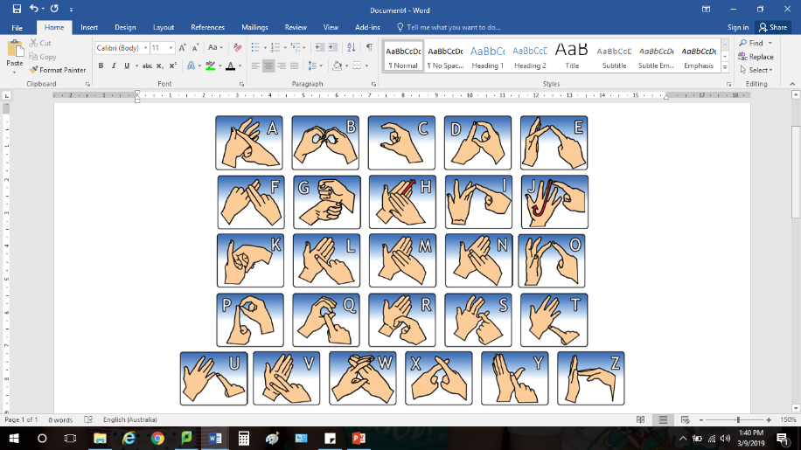This year, all Hallam PS students will continue learning how to communicate using **Au**stralian **S**ign **Lan**guage (Auslan). Auslan relies on a combination of hand shapes, movements and facial expressions to deliver messages.

Around 20,000 Australians use Auslan to communicate every day. Many commonly used words have their own unique sign. When there isn’t an agreed sign for a particular word, fingerspelling is used. Please ask your child’s class teacher if you would like to receive a printed copy of the fingerspelling alphabet.

**The Arts 2024**

In the Victorian Curriculum, the Arts includes Dance, Drama, Music, Media Arts and Visual Arts. Students from Prep to Year 6 attend one 60-minute Visual Arts session and one 60-minute session of Performing Arts each week.

**VISUAL ARTS**

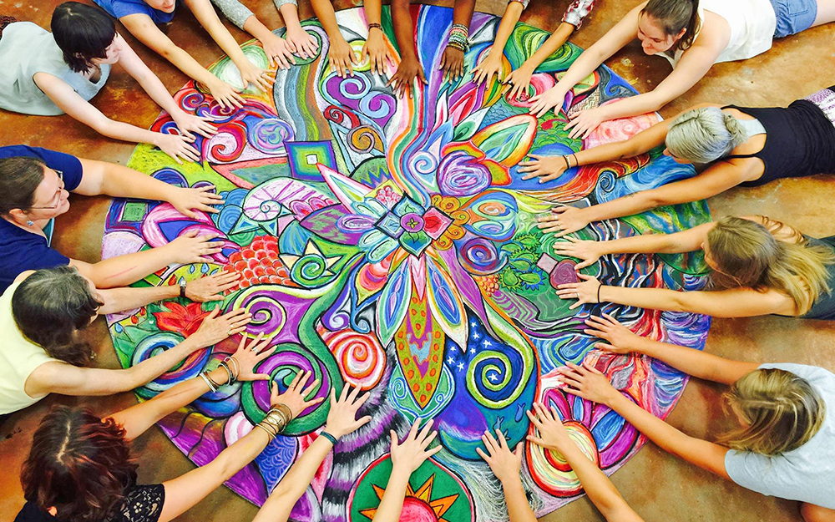In 2024, students will engage in activities based on four topics.

1. Individuality: Students will discover how artists express their individuality through their art.
2. Indigenous arts: Students will focus on the significant contributions made to the visual arts by First Nations peoples.
3. Ice: Students will investigate and create artworks inspired by the diverse species that inhabit the Polar Regions.
4. Industrialisation: Students will learn about the ways technology inspired different styles of art throughout history.

Within these topics, students learn the design elements and principles fundamental in creating, making and responding to many works of art. During each session, they will explore techniques used by historic and contemporary artists, locally and globally. Students will develop skills in areas such as painting, drawing, collage, construction, printmaking, digital arts and modelling.

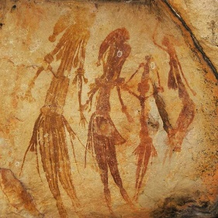Visual Arts help students become confident and creative individuals who enrich our Australian society.

Mrs Cheryl King

Visual Arts teacher

**Health and Physical Education**

The Health and Physical Education Program consists of a 60-minute specialist session, 90-minute Friday Sport training and regular fitness sessions taken by the classroom teachers each week. The Physical Education lessons aim to develop students’ skills and knowledge across areas of movement/co-operative team games, invasion games, Handball, Australian Rules, Netball, Athletics, Basketball, Hockey, T-Ball, Soccer, Coaching Games, physical fitness and sport education.

Students participate in a variety of activities, drills and games, and full participation is an expectation. The students are also encouraged to develop qualities of good sportsmanship such as fair play and teamwork.

***School hats are compulsory during Terms 1 and 4, and it is recommended that students wear appropriate footwear. Students are also expected to bring a drink bottle (water only) to all Physical Education sessions.***

In addition to lessons, students will be given opportunities to participate in a variety of sports clinics, 5/6 Interschool Sport Gala Days, a swimming program (Big Fish Little Fish) and whole school sports events such as the Colour Fun Run and Hallam Olympics Day. All 5/6 students will also have the opportunity to try out for District events such as Swimming, Cross Country and Athletics Carnivals to represent Hallam Primary School. Dates and information for these programs will be distributed at relevant times throughout the year.

**5/6 Day Camp – Term 4**

In Term 4, 5/6 students will have the opportunity to participate in a day adventure camp, dates and location to be confirmed. More information about the camp will be distributed in Term 3.

**Mr Rob Coxon**

**Physical Education Program Coordinator**

S T E M

Students from Prep to Year 6 will take part in a one-hour STEM lesson each week. This creates links between Science, Technology, Engineering and Mathematics through expansion of student’s vocabulary and knowledge.

Students will work on developing experimental, observational and teamwork skills. Lessons will explore ‘Science as a Human Endeavour’ and will develop ‘Science Inquiry Skills.’ Throughout the year students will be exposed to the four conceptual Science strands of **Biological**, **Earth and Space**, **Chemical** and **Physical** sciences. Students will be given the opportunity to explore Living Things and Organisms, Geography, Properties of Materials and Energy.

The Digital Technologies curriculum, Data and Information, Creating Digital Solutions and Digital Systems, will be incorporated into each unit of work. Students at each year level will be exposed to different digital resources including 3D-Printing, Green Screen, HTC Vive VR, iPads – including AR apps, Google Apps for Education and LEGO kits. Students will be given the opportunity to use coding and programming software including Scratch and Scratch Jnr. They will also operate robots such as Bee-Bots, Dash and Dot, NAO and their associated programs.

Term 1: 5/6s will learn that living things have structural adaptations that help them survive in their environment. Students will program NAO robots and use Green Screen to create a short video.

Term 2: 5/6s will learn that Earth is part of a solar system and it orbits around the Sun. Students will use the HTC Vive VR headset to explore space and create an interactive game using the Scratch application.

Term 3: 5/6s will learn about reversible changes such as melting, freezing and evaporation. Students will also learn about irreversible changes such as burning and rusting. Students will use Lego kits to look at reversible changes.

Term 4: 5/6s will learn about sources of energy. They will look at electric circuits and how energy is transferred to another place to form another energy. Students will use Tinkercad to explore electrical circuits in a safe way.

The STEM lesson format incorporates the school instructional design process:

* Introduction - Looking at imagery, video clips, instructions and demonstrations
* Embedded Learning - Activities, experiments, engineering and observations
* Reflection - Discussion and evaluation

Through participation in regular STEM lessons, we want our students to:

* Be interested in and understand the world around them
* Engage in discussions about Science, Technology, Engineering and Mathematics
* Be able to identify questions, investigate and draw evidence-based conclusions
* Make informed decisions about the environment and their own health and wellbeing
* Follow the Engineering Design Process (Ask, Brainstorm, Plan, Build, Experiment, Improve)
* Develop skills to utilise technology effectively

At Home: Great resources for students to try at home to help consolidate topics are:

|  |  |
| --- | --- |
| <https://www.abcya.com/games/category/science> | <https://pbskids.org/games/science> |
| <http://www.code.org> | <https://pbskids.org/games/engineering> |

**Miss Amy Kong**

**STEM Teacher**

**Performing Arts**

**Year 5/6**

Students in Years 5/6 participate in a one-hour Performing Arts session each week with Amanda Conder.

During Performing Arts sessions, students have the opportunity to develop their creative and expressive capacities by learning about the different practices, disciplines and traditions that have shaped the expression of culture locally, nationally and globally. Students are both artist and audience in the Arts. They make and respond, and learn to appreciate the specific ways this occurs in different disciplines. Performing Arts sessions focus on Music, Dance and Drama.

Music Education is fundamental to the learning of every individual because music is a language that integrates into all cultures and societies. The aim is to stimulate, develop and maintain an interest in, and a love of, music. Music develops students’ imaginations, builds self-confidence, self-awareness and strengthens interpersonal skills.

All students will have access to a wide range of experiences, from traditional instrumental playing to performance and composition. Students explore and extend their knowledge of time signatures and their relationship to music they listen to today.  The music program focuses on a variety of learning methods including Orff, The Black Belt Recorder and Ukelele Programs. Music sessions include a high level of engagement, motivation, creativity, learning and most of all FUN.

The students structure movements in dance sequences and use elements of dance and choreographic devices to make dances that communicate ideas and intentions. They perform dances for audiences, demonstrating technical and expressive skills and safe dance practice.

Students actively use body, gesture, movement, voice and language, taking on roles to explore and depict real and imagined worlds. Props, puppets, music, percussion instruments and costumes are used to enhance performances. Students create meaning as drama makers, performers and audiences as they enjoy and analyse their own and others’ stories and points of view.

Students create, rehearse, perform and respond using the elements and conventions of drama and emerging and existing technologies available to them.

**Recorders:** Students in Years 5/6 participate in the IJAM Black Belt Recorder Program. Students require their own recorders and ‘yellow’ student books for this program.

**Lunchtime Programs**: Throughout the year students can participate in a variety of lunchtime programs including, musical theatre/choir, Wakakirri and recorder sessions.

**Mrs Amanda Conder**

**Performing Arts Specialist**